Half Yearly Progress Report on Research Work carried out from 28.09.2013 to 27.03.2014
Name and address of the candidate : P. Mohandass
Reg. No. P8851
PG and Research Dept. of Chemistry
Saraswathi Narayanan College
Madurai-22.

Occupation if any and address : Associate Professor of Chemistry
Saraswathi Narayanan College
Madurai-22.

Name, designation and address of the : Dr. K. Radhakrishnan
Guide Associate Professor of Chemistry
Saraswathi Narayanan College
Madurai-22.

College where the candidate carried : PG and Research Dept. of Chemistry
out the research Saraswathi Narayanan College
Madurai-22.

Whether the candidate has paid annual
Research fee (mention amount, date of : No
remittance, place of bank, etc.)

Detailed one page report on the progress : Separate sheet Attached
of research work carried out by the
candidate (attach separate sheet)

Remark, if any by the guide : Nil

Signature of the candidate Signature of the research supervisor

Half Yearly Progress Report on Research Work carried out from 28.09.2013 to 27.03.2014

Characterization of (E)-1-(furan-2-yl)-3-phenylprop-2-ene-1-one and its derivatives.
All the compounds were characterized as (E)-1-(furan-2-yl)-3-phenylprop-2-ene-1-one and its derivatives (Fig.1) by ¹H and ¹³C NMR spectral techniques. All ¹H and ¹³C NMR spectra were obtained on a BRUKER AV 400 MHz spectrometer. Chemical shifts of ¹H were measured with the central peak of CDCl₃ at δ 7.259 as the internal reference, while those of ¹³C were measured with the central peak of CDCl₃ at δ 77.54 as the internal reference.
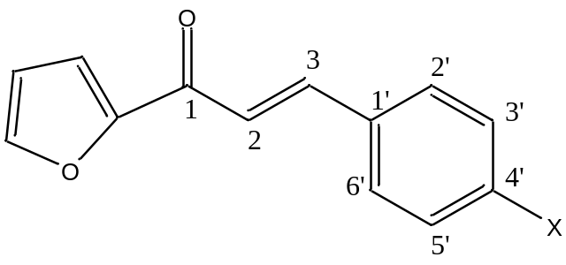
Figure 1
where X is the substituents viz. -NMe₂, -Me, H, -Cl, -F, -CHO.

Signature of the research supervisor

